In building this dashboard, we'll create individual pages for each plot and a means by which we can navigate between them. These pages will contain the visualizations and their corresponding explanations. We'll also have a landing page, a page where we can see a comparison of all of the plots, and another page where we can view the data used to build them.

<div class="backgroundcontainer">

<img src="blue-clouds-day-53594.jpg" alt="Snow" style="width:100%;">

</div>

<img src="blue-clouds-day-53594.jpg" alt="bckgound" class="bg" />

<div style="background-color:white;background-image:url(//www.html.am/images/backgrounds/background-image-2.gif);border:1px solid black;width:300px;height:300px;font-size:18px;">HTML background image example</div>

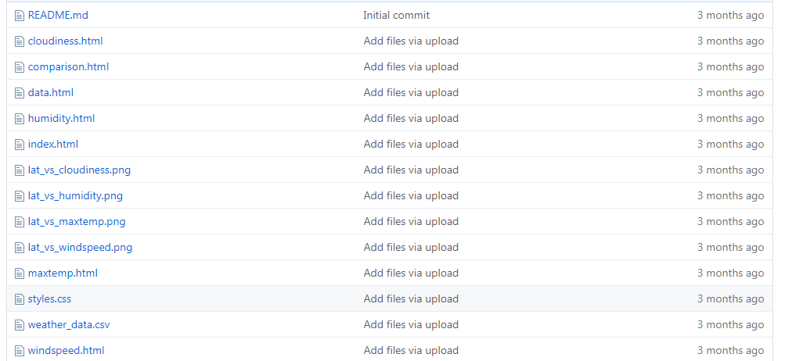

**### Website Requirements**

<https://github.com/petrospat/Homework9-Web-Visualization>

The website must consist of 7 pages total, including:

Page 1 – Landing Page

* An explanation of the project.

* Links to each visualizations page.

Pages 2,3,4,5

* Four visualization pages, each with:

* A descriptive title and heading tag.

* The plot/visualization itself for the selected comparison.

* A paragraph describing the plot and its significance.

Page 6

* A "Comparisons" page that:

* Contains all of the visualizations on the same page so we can easily visually compare them.

* Uses a bootstrap grid for the visualizations.

* The grid must be two visualizations across on screens medium and larger, and 1 across on extra-small and small screens.

Page 7

* A "Data" page that:

* Displays a responsive table containing the data used in the visualizations.

* The table must be a bootstrap table component.

* The data must come from exporting the `.csv` file as HTML, or converting it to HTML. You may use a csv-to-html table conversion tool, e.g. [ConvertCSV](http://www.convertcsv.com/csv-to-html.htm).

Every Page Requirement:

The website must, at the top of every page, have a navigation menu that:

* Has the name of the site on the left of the nav which allows users to return to the landing page from any page.

* Contains a dropdown on the right of the navbar named "Plots" which provides links to each individual visualization page.

* Provides two more links on the right: "Comparisons" which links to the comparisons page, and "Data" which links to the data page.

* Is responsive (using media queries). The nav must have similar behavior as the screenshots "Navigation Menu" section (notice the background color change).

**### Considerations**

* You may use the [weather data](Resources/cities.csv) or choose another dataset. Alternatively, you may use the included [cities dataset](Resources/cities.csv) and pull the images from the [assets folder](Resources/assets).

* You must use bootstrap. This includes using the bootstrap `navbar` component for the header on every page, the bootstrap table component for the data page, and the bootstrap grid for responsiveness on the comparison page.

* You must deploy your website to GitHub pages, with the website working on a live, publicly accessible URL as a result.

* Be sure to use a CSS media query for the navigation menu.

* Be sure your website works at all window widths/sizes.

* Feel free to take some liberty in the visual aspects, but keep the core functionality the same.

**### Bonuses**

* Use a different dataset! The requirements above still hold, but make it your own.

* Use a bootstrap theme to customize your website. You may use a tool like [Bootswatch](https://bootswatch.com/). Make it look snazzy, give it some attitude. If using this, be sure you also meet all of the requirements listed above.

* Add extra visualizations! The more comparisons the better, right?

* Use meaningful glyphicons next to links in the header.

* Have visualization navigation on every visualizations page with an active state. See the screenshots below.

**### Screenshots**

This section contains screenshots of each page that must be built, at varying screen widths. These are a guide; you can meet the requirements without having the pages look exactly like the below images.

**#### Landing page**

Large screen:

![Landing page large screen](Images/landing-lg.png)

A screenshot of a cell phone

Description generated with very high confidence

Small screen:

![Landing page small screen](Images/landing-sm.png)

A screenshot of a cell phone

Description generated with very high confidence

**#### Comparisons page**

Large screen:

![comparison page large screen](Images/comparison-lg.png)

A screenshot of a cell phone

Description generated with very high confidence

Small screen:

![comparison page small screen](Images/comparison-sm.png)

A screenshot of a cell phone

Description generated with very high confidence

**#### Data page**

Large screen:

![data page large screen](Images/data-lg.png)

A screenshot of a cell phone

Description generated with very high confidence

Small screen:

![data page small screen](Images/data-sm.png)

A screenshot of a cell phone

Description generated with very high confidence

**#### Visualization pages**

You'll build four of these, one for each visualization. Here's an example of one:

Large screen:

![visualize page large screen](Images/visualize-lg.png)

A screenshot of a cell phone

Description generated with very high confidence

Small screen:

![visualize page small screen](Images/visualize-sm.png)

A screenshot of a cell phone

Description generated with very high confidence

**#### Navigation menu**

Large screen:

![nav menu large screen](Images/nav-lg.png)

A close up of a logo

Description generated with high confidence

Small screen:

![nav menu small screen](Images/nav-sm.png)

A screenshot of a cell phone

Description generated with very high confidence